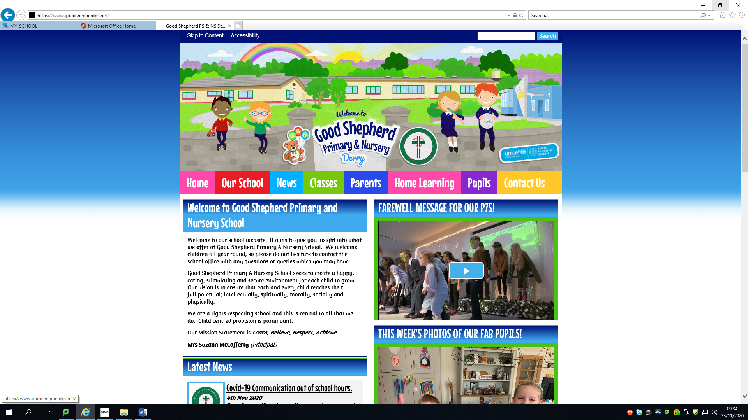

**February 2024 Newsletter**



As part of Safer Internet Day, we are holding an information session for Parents/Guardians on Tuesday 6th February 2024 in the school at 6-7pm.  This is being facilitated by Mr Harvey and Mr McAleer from All State NI. This is a **very worthwhile event** and aims to keep Parents/Guardians informed on how to keep your child safe online. **This information session will run during the Nursery’s big bedtime read. All welcome to attend!**

**_____________________________________**

FAO: All Parents/Guardians of Primary 7 pupils.

Important dates for admissions to post primary schools

* Thursday 11 January 2024: Admissions criteria for Post Primary Schools published on the EA website.
* **Tuesday 30 January 2024 - at 12 noon:EA Connect opens for online applications for Post Primary.**
* **Thursday 22 February 2024 - at 12 noon: EA Connect closes for online applications for Post Primary.**
* Monday 4 March 2024 – by 4pm: Final date for late paper applications.
* Saturday 18 May 2024:Parents/carers will receive application outcome via email (where one is held) or by letter.

Admissions criteria for local schools can be found here: <https://www.goodshepherdps.net/parents-area/post-primary-admissions-criteria/>

All information on how to apply can be found here:

<https://www.eani.org.uk/parents/admissions/post-primary-admissions-guide>

If you require any help or assistance, please contact the school office to make an appointment with Mrs McCafferty.

**_________________________________________________________________**



From Monday 5th February we will be raising awareness of autism and promoting understanding through lessons which focus on tolerance, respect and individuality throughout our school. Our student council have suggested the following tasks at home to also raise awareness:

Superhero Tasks for the Week:

* Be as strong as a superman and help carry the shopping
* Be as smart as ironman and do your homework
* Be as kind as wonder woman and feed your pets or the birds
* Be as generous as black panther and set the table
* Be amazing like spiderman and keep your room tidy



On Friday 9th February- Rock Red Friday. Wear something red/non-uniform and bring in £1 (£2 max. per family) in aid of The Children’s Heartbeat Trust.

**_______________________________________________**

We are delighted to inform you that our Primary 3 children will be participating in a 5 week Paired Reading Programme. This aims to significantly improve their confidence and reading fluency. **An information session with Mrs McCafferty will be held for Parents/Guardians on Thursday 8th February at 2.20pm in the school assembly hall about this initiative.**

**_________________________________________________________________**

We are delighted to welcome Ardmore Cricket Club and Cricket Coaching by North West in each Friday to coach our Primary 7 children.

What’s on at Good Shepherd Primary & Nursery School?

|  |  |
| --- | --- |
| **Date** | **What’s on?** |
| **Thursday 1st February** | P1 Health Update with School Nurse |
| **Friday 2nd February** | Primary 6PH Assembly @9.30am in the assembly hall-all welcome |
| **Friday 2nd February** | P5SM Swimming |
| **Monday 5th February** | After School R9 Sports P1 & P2: 2-3pm,  P3 P4 P5 P6 P7: 3-4pm. Week 5 |
| **Monday 5th February** | Autism Superhero Week |
| **Monday 5th February** | After School Mini Professors P1 & P2: 2-2.50pm,  P3 & P4: 3-3.50pm Week 5 |
| **Tuesday 6th February** | Safer Internet Day- Parent/Guardian information session @6-7pm in the assembly hall |
| **Tuesday 6th February** | P1 Health Update with School Nurse |
| **Tuesday 6th February** | Nursery Big Bedtime Read 6-7pm |
| **Tuesday 6th February** | P6 internet safety workshop |
| **Tuesday 6th February** | Chess Club 3-4p, P5, P6 & P7 Week 4 |
| **Tuesday 6th February** | After School Singing lessons P1 & P2 2-2.45pm,  P3, P4, P5, P6 & P7 3-3.45pm Week 5 |
| **Wednesday 7th February** | After School Dance P1 & P2: 2-3pm,  P3 P4 P5 P6 P7: 3-4pm Week 5 |
| **Wednesday 7th February** | After School Guitar Lessons P5, P6 & P7 Week 7 |
| **Thursday 8th February** | After School Maiden City Soccer P1 & P2: 2-3pm,  P3, P4, P5, P6 & P7: 3-4pm Week 2 |
| **Thursday 8th February** | P1 Health Update with School Nurse |
| **Thursday 8th February** | P3 Parent/Guardian paired reading information session with Mrs McCafferty @2.20pm in the assembly hall |
| **Friday 9th February** | Primary 6MG Assembly @9.30am in the assembly hall- all welcome! |
| **Friday 9th February** | P5SM Swimming |
| **Friday 9th February** | Rock Red Friday- wear something red/non uniform. £1 donation/£2 per family for the Children’s Heartbeat Trust. |
| **School closed to all pupils Monday 12th February-Friday 16th February** | |
| **Monday 19th February** | After School R9 Sports P1 & P2: 2-3pm,  P3 P4 P5 P6 P7: 3-4pm. Week 6 |
| **Monday 19th February** | P3 Paired Reading Programme begins for 5 weeks |
| **Monday 19th February** | After School Mini Professors P1 & P2: 2-2.50pm,  P3 & P4: 3-3.50pm Week 6 |
| **Tuesday 20th February** | After School Singing lessons P1 & P2 2-2.45pm,  P3, P4, P5, P6 & P7 3-3.45pm Week 6 |
| **Tuesday 20th February** | Chess Club 3-4pm P5, P6 & P7 Week 5 |
| **Date** | **What’s on?** |
| **Wednesday 21st February** | After School Dance P1 & P2: 2-3pm,  P3 P4 P5 P6 P7: 3-4pm Week 6 |
| **Wednesday 21st February** | After School Guitar Lessons P5, P6 & P7 Week 8 |
| **Thursday 22nd February** | After School Maiden City Soccer P1 & P2: 2-3pm,  P3, P4, P5, P6 & P7: 3-4pm Week 3 |
| **Friday 23rd February** | P5SM Swimming |
| **Monday 26th February** | After School R9 Sports P1 & P2: 2-3pm,  P3 P4 P5 P6 P7: 3-4pm. Week 7 |
| **Monday 26th February** | After School Mini Professors P1 & P2: 2-2.50pm,  P3 & P4: 3-3.50pm Week 7 |
| **Tuesday 27th February** | After School Singing lessons P1 & P2 2-2.45pm,  P3, P4, P5, P6 & P7 3-3.45pm Week 7 |
| **Tuesday 27th February** | Chess Club 3-4pm P5, P6 & P7 Week 6 |
| **Wednesday 28th February** | After School Dance P1 & P2: 2-3pm,  P3 P4 P5 P6 P7: 3-4pm Week 7 |
| **Wednesday 28th February** | After School Guitar Lessons P5, P6 & P7 Week 9 |
| **Thursday 29th February** | After School Maiden City Soccer P1 & P2: 2-3pm,  P3, P4, P5, P6 & P7: 3-4pm Week 4 |

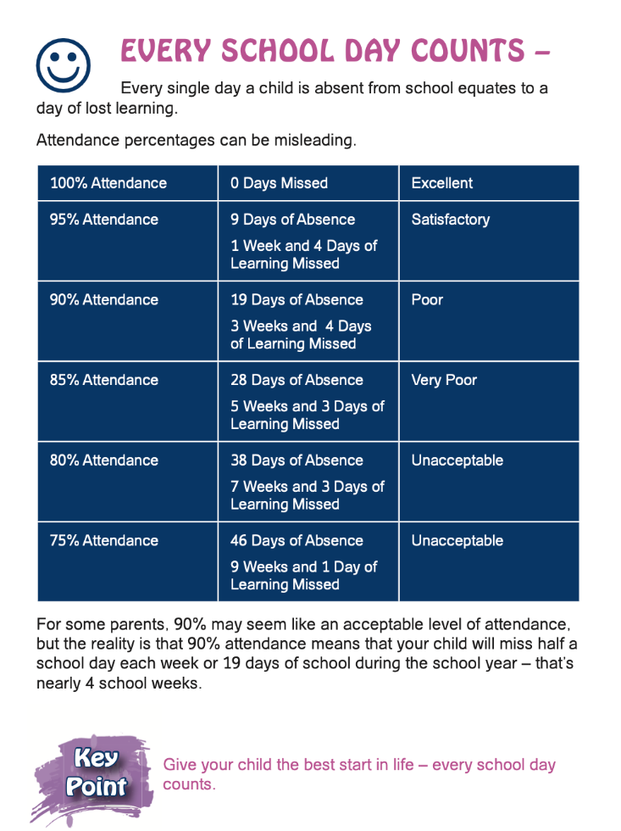

Please contact the school office to inform us if your child is not at school. Thank You!

**Teaching and learning starts at 9am every day**. It is important that your child is punctual for school. School gates open from 8.45am. **Breakfast club is open from 8.10-8.30am. No need to book in for the breakfast club- £1 a day per child. Please enter the school grounds via the Nursery pedestrian gate.** In the interests of health and safety, children should not be left unsupervised at the school gates before they open.

**Safeguarding Information**

**In the interests of health and safety we now ask that children do not bring any shellfish products or nut products to school for either break or lunch. This includes Nutella.**

**Safeguarding Information**

Please be mindful that at present **we have no school crossing patrol**. This post will be advertised with the Education Authority soon.

We would like to take the opportunity to remind parents/guardians that **no cars are permitted inside the school grounds at any time** unless this has been pre-arranged with Mrs McCafferty or you are a blue badge holder.  Please share this information with grandparents and childminders as refusal often causes offence.  **Please ensure that the school gates are kept clear.  Cars should not be parked on the yellow zigzag lines outside the school gates at any time.** Please talk to your child about general road safety.  Enter and exit the school using the pedestrian gates only. Once your child is collected from school, please keep them beside you at all times. These measures are in the interest of everyone's health and safety. Thank you!

**Members of the Schools Safeguarding team are:**

The Chair of the Board of Governors (Mr P. Duffy)

The Designated Governor for Child Protection (Dr M Gormley)

The Designated Teacher for Child Protection (Mrs Maria Harley)

Deputy Designated Teacher for Child Protection (Mrs S. McCafferty).

Other members of Safeguarding Team:

Mrs P. Houston/Mrs R Warne /Mrs Kyle/ Mrs A Kivlehan/Mr D Herron.

School policies can be found on the school website under the ‘My School’ section. There is also a wide range of support information for parents in the ‘Parents Section’ of the school website. This is updated regularly.

The school holiday list can be accessed here: <https://www.goodshepherdps.net/parents-area/holiday-list/>

The school dinner menu can be accessed here- please check which week we are on as there is a 4 week menu:

<https://storage.googleapis.com/siteassetsswd/475/docletter/20230831124550_96_NEW_SEPTEMBER_DINNER_MENU_2023.pdf>



Please ensure that you download the Schools NI App which is linked to our website. Click on the ? on the app and ensure that notifications are turned on. This is our central means of communication.

Thank you to our entire school community for your continued support.