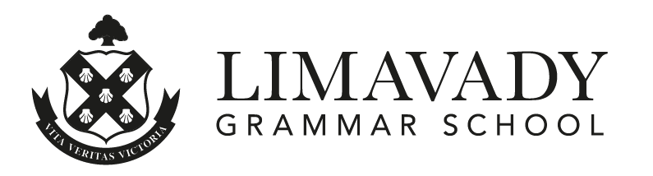

10 May 2022

Dear Year 6 Parent/Guardian

As you are aware we were unable to hold our annual Open Night in school in January and I would like to extend the opportunity for you and your child to visit Limavady Grammar School on Wednesday 22 June 2022 for an Open Evening.

During this evening you and your child will have an opportunity to tour the school and meet our pupils and staff. The evening will commence with a short presentation in which I will briefly outline the key elements of the AQE application process and main features of the school. After this you will be able to see all that is on offer in Limavady Grammar School for your child. Please note the application process is now open for applications for the AQE Assessments in November/December 2022.

In order to facilitate planning for this event and enable social distancing, we will allocate you a slot for arrival. This will allow us to manage numbers within school and to organise groups for tours.

Please complete the online form indicating your first and second choice of time. The evening will run from 5.30 pm until 8.30 pm. On completion of the online booking form we will contact you via email with your allocated time.

Online booking form:

https://forms.gle/6crUfW4jR9656aSD8

Please note that this Open Evening is only for pupils who are currently in P6. We hope that this will be a fun and enjoyable evening that will give your child an opportunity to experience Limavady Grammar School. Tours can be booked until 01 June 2022 at 3.00 pm. This booking system will close after this date. Unfortunately, we will not be able to accommodate visits at any other time this term.

Looking forward to meeting you at our AQE Information and Open Evening.

Yours sincerely

NJ Madden (Mrs)
Principal

