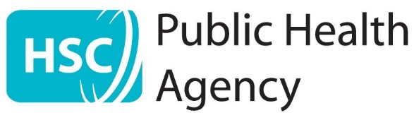

Tuesday 1st February 2022

ADDITIONAL LATERAL FLOW DEVICE TESTING IN CLASSES WITH A NUMBER OF CASES OF COVID-19

Dear Parent/Guardian,

The school has been notified of a number of confirmed cases of COVID-19. All those who were high risk close contacts of the cases will have been identified, advised on self-isolation and testing by the PHA Contact Tracing Service.

It is inevitable that with high cases of Omicron in the community there will also be cases reported in school age children. The school is taking actions to minimise in-school transmission, following guidance from the Public Health Agency and the Education Authority.

Some people can have active COVID-19 infection but have no symptoms, so when there are high numbers of confirmed cases in a class a one-off test is recommended to the rest of the class to identify other infected children or staff as early as possible so that they can self-isolate.

Even if your child has no new symptoms, we are asking pupils in Mrs McCormack’s P3 class to undertake a lateral flow COVID test (LFT) at home before coming back into school.

If the Lateral Flow test is negative, and your child has no symptoms, your child can return to school.

If the lateral flow test is positive your child should isolate immediately and is now to be treated as a case of Covid-19. They do not need to have a PCR test. It is extremely important that you report your child’s positive lateral flow test online using the link: https://www.gov.uk/report-covid19-result Report a COVID-19 rapid lateral flow test result - GOV.UK (www.gov.uk). This will trigger contact tracing processes to alert those your child has been in close contact with and to provide them with advice regarding their potential to become infected and spread the virus. You should also inform the school.

How to order a lateral flow test
You can order these tests online, ring 119, or collect from a local pharmacy. Details are available on the following link: https://www.health-ni.gov.uk/rapid-tests

How to book a PCR test if your child develops symptoms
If the lateral flow test is negative but your child develops new symptoms, please book a PCR test online at www.gov.uk/get-coronavirus-test or by phoning 119. You can choose your closest testing site or request a postal kit which will be sent to your home. Going for a COVID test is one of the reasons your child can leave home during the self-isolation period, however they should not use public transport. Please order a postal test if you do not have private transport to a test site.

Please see Coronavirus (COVID-19): self-isolating and close contacts | nidirect for guidance on whether other people in your household also need to self-isolate and take tests while you are waiting for your child’s PCR result.

Help stop COVID-19 spreading
If you or your child are eligible, getting your free vaccination and taking part in regular lateral flow testing if that is offered to you will help reduce the risk of you and anyone you live with getting ill with COVID-19. More information on protecting yourself and your family is available at: Coronavirus (COVID-19): keeping your household safe from COVID-19 | nidirect

I know that organising tests and staying at home waiting for results may be hard for you and your child but it is vital to help reduce the risk of transmission in the school community.

Your support is very much appreciated.

Yours sincerely

Mrs S. McCafferty

