Good Shepherd Primary & Nursery School

Misuse of Drugs Policy

UNCRC Article 33: you have the right to be protected from drugs

Signed by the Chair of the BOG:______________________

Date ratified by the BOG:_____________

Rationale
We believe that Good Shepherd Primary & Nursery School has a vital preventative role to play in combating the misuse of drugs by young people and we therefore include a drugs education programme in our curriculum. There is a complimentary policy on Drugs Education in place.

This school sees its role as that of a caring community committed to the physical, mental, social, emotional, moral and spiritual health, safety and well-being of our pupils and staff.

We want our pupils to make informed and responsible decisions about drugs by increasing their knowledge and by developing in them appropriate values, attitudes and skills. However, we recognise that drug misuse is a whole-community issue and that schools alone cannot solve the drugs problem; the school is only one of a number of groups and agencies which must play a part in the education of young people and we make use of their expertise where possible in the delivery of the programme.

For the purpose of this document the term ‘drugs’ includes tobacco, alcohol, over-the-counter and prescribed medication, volatile substances and controlled drugs. This school does not condone the misuse of drugs. We recognise that there has been a considerable increase in the abuse of drugs in recent years in Northern Ireland. Drug misuse appears to be affecting an ever-younger population and the so-called "recreational" use of drugs can lead to a dangerous acceptance of illegal and harmful drug misuse as part of everyday life.

Copies of the guidance on which this policy is based (Drugs: Guidance for schools in Northern Ireland) are available from the Department of Education website www.deni.gov.uk (Circular 2004/09 and 2015/23).

Definitions
For the purpose of this document and in line with the guidance issued to all schools by the Department of Education (2004/09 and 2015/23) the term drugs includes any substance which, when taken, has the effect of altering the way the body works or the way a person behaves, feels, sees or thinks.
As well as everyday substances such as tea and coffee, drugs include:
- alcohol and tobacco;
- E cigarettes (banned on school premises by DE Circular 2014/25)
- “over-the-counter” medicines, such as paracetamol;
- prescribed drugs, such as antibiotics, tranquillizers, inhalers and Ritalin;
- volatile substances, such as correcting fluids/thinners, gas lighter fuel, aerosols, glues and petrol;
- controlled drugs, such as cannabis, LSD, Ecstasy, amphetamine sulphate (speed), magic mushrooms (processed), heroin and cocaine;
- new psychoactive substances (NPS), formerly known as legal highs*, which contain one or more chemical substances that produce similar effects to illegal drugs and are sold as incense, salts or plant food and marked ‘not for human consumption’ to avoid prosecution; and
- Other substances such as amyl/butyl nitrite (‘poppers’) and unprocessed magic mushrooms.

Ethos
Good Shepherd Primary & Nursery School is a Rights Respecting School. We aim to nurture close links and support for our pupils, parents, staff and local community. As a Catholic school, we promote faith, high academic achievement and lifelong learning.
We are firmly committed to:
- Creating a happy, caring, stimulating and secure environment for each child
- Developing in each child, Christian values, self-esteem and respect for others
- Promoting our school as a provider of quality education, with the co-operation of the wider community
- Developing enquiring minds and a sense of curiosity
- Nurturing talents, skills and interests
- Developing the academic, physical, social, moral and emotional abilities of each child so that each child can reach his/her potential
- Ensuring the inclusion of all pupils
- Always striving for better
We ensure that each child will achieve success through experiencing:
- A broad, balanced and challenging curriculum
- A stimulating learning environment
- A varied programme of extra-curricular activities and school visits
- An ethos that is supportive, encouraging and friendly
- An effective partnership between school, home and the wider community
- A variety of teaching approaches and strategies to meet the needs and learning styles of pupils
- Access to a range of varied and up-to-date resources
We demonstrate our commitment to working as a learning community by:
- Ongoing self-evaluation to ensure our vision is achieved
- Working collaboratively with all our stakeholders
Our Mission Statement is ~ Learn ~ Believe ~ Respect ~ Achieve ~

Aims and Objectives
- To have a clear and agreed understanding among everyone in the school community about the implications and possible consequences of drug use/misuse.

- To provide all staff (teaching and non-teaching) with adequate training and support to enable them to deal effectively and confidently with incidents of suspected drug misuse, and to ensure that the agreed procedures are consistently and sensitively applied in all situations.

- To empower teaching staff through appropriate training and support to develop and deliver an effective drug education programme.

- To provide a drug education programme which:
- develops pupils’ self-esteem and promotes positive attitudes in their relationships with others;

- gives pupils’ opportunities to develop the values, skills, knowledge and understanding necessary to make informed and responsible decisions about the use/misuse of drugs including tobacco, alcohol and volatile substances, within the context of a healthy lifestyle; and

- Helps pupils develop the skills necessary to assert themselves confidently and resist negative pressures and influences.

- To provide appropriate support and assistance for those pupils affected by drug-related issues.

- To inform parents of the content of this policy and the procedures to be implemented in the management of incidents of suspected drug misuse.

- To establish an environment in which the school is free from the misuse of all drugs.

Roles and Responsibilities

The Board of Governors
The BOG understand their responsibilities for our school. They collaborate with staff, pupils and parents or carers as appropriate in the development and review of our Misuse of Drugs Policy. They also:

- Ensure the policy is published and that it is reviewed at regular intervals.
- Be fully aware of the procedures required to deal with suspected drug related incidents, including tobacco and alcohol, tobacco related products, electronic cigarettes, and their appropriate disciplinary response.
- The Designated Governor for Safeguarding and Child Protection is also the Designated Governor for Drugs (Mrs M. Hegarty) and will work with Mrs S. McCafferty who is the Designated Teacher for Drugs and Mrs M. Harley (DTCP) in relation to drug related issues.

The Principal
It is the Principal’s responsibility to determine the circumstances of all incidents, but it is the responsibility of the PSNI to investigate any criminal or suspected criminal offence. In any suspected drug-related incident, the Principal should contact the parents or carers of those pupils involved. The Principal must ensure that in any incident involving a controlled substance there is close liaison with the PSNI. Failure to inform the PSNI of a suspected incident involving controlled drugs is a criminal offence.

After contacting the PSNI, the Principals will confine their responsibilities to:
- the welfare of the pupil(s) involved in the incident and the other pupils in the school;
- health and safety during the handling, storage and safe disposal of any drug or drug related paraphernalia, using protective gloves at all times;
- informing the Board of Governors;
- agreeing any appropriate pastoral or disciplinary response;
- reporting the incident to the Education Authority or CCMS if appropriate, for example if an incident:
- is serious enough to require PSNI involvement;
- requires that a child protection procedure is invoked; or
- leads to the suspension or exclusion of a pupil; and
- completing a written report and forwarding a copy to the Board of Governors and the designated officer in the Education Authority and CCMS.
- ensure that members of the Board of Governors have been consulted on and ratified the policy.

The Designated Teacher for Drugs (Principal) The designated teacher is responsible for:
- co-ordinating the school’s procedures for handling suspected drug-related incidents and training staff in these procedures;
- ensuring that the school’s disciplinary policy has an appropriate statement about any disciplinary response resulting from suspected drug-related incidents;
- ensuring that the school’s Pastoral Care Policy has an appropriate statement about any pastoral response resulting from suspected drug-related incidents;
- liaising with other staff responsible for pastoral care;
- being the contact point for outside agencies that may have to work with the school or with a pupil or pupils concerned;
- responding to advice from first aiders, in the event of an incident, and informing the Principal, who should contact the pupil’s parents or carers immediately;
- taking possession of any substance(s) and associated paraphernalia found in a suspected incident;
- completing a factual report using the schools Drug-Related Incident Form, which they forward to the
Principal; and
- reviewing and if required updating the policy at least every three years or after a drug-related incident, where learning from the experience could improve practice.

All staff (teaching and non-teaching)
All staff should be familiar with the content of the school’s Misuse of Drugs Policy. They should also be fully aware of their responsibilities, should a suspected drug-related incident occur. It is not the staff’s responsibility to determine the circumstances surrounding the incident or carry out an investigation, but they should:

- assess the situation and decide on the appropriate actions to take;
- notify the principal and the designated teacher for drugs at the earliest opportunity;
- deal with any emergency procedures to ensure the safety of pupils and staff, if necessary (see Appendix 4.2);
- forward any information, substance or paraphernalia received to the designated teacher for drugs, who will respond accordingly (see Appendix 4.1);
- use the school’s Drugs Incident Report Form to complete a brief factual report on the suspected incident and forward this to the designated teacher for drugs (see Appendix 1);
- consider the needs and safety of a pupil when discharging him or her into the care of a parent or carer who appears to be under the influence of alcohol or another substance (staff, who are in loco parentis, should maintain a calm atmosphere when dealing with the parent and, if concerned, should discuss with the parent alternative arrangements for caring for the pupil); (see Appendix 4.5) and
- invoke safeguarding procedures, if a parent or carer’s behaviour may place a pupil at risk (see Appendix
4.5).
- forward any information, substance or paraphernalia to the designated teacher for drugs who may have to take immediate action.

Teachers delivering the Drug Education programme in addition to the above:
- Deliver the school’s drug education through the PDMU programme.
- Create an atmosphere in the classroom in which pupils can freely contribute to discussion, safe in the knowledge that the comments, ideas and feelings of the group are valued.
- Support pupils in their class if necessary.
- Liaise with the PDMU Coordinator regarding any aspect of the programme/policy, as necessary

The Building Supervisor
- Be vigilant around and conduct regular checks of the school grounds for drug-related paraphernalia, and inform the designated teacher for drugs as appropriate.
- Ensure the safe storage, handling and disposal of potentially harmful substances such as solvents and cleaning fluids.

Pupils
• Be aware of and adhere to school rules in relation to drug use/misuse, including tobacco, alcohol, overthe-counter and prescribed medication, volatile substances and controlled drugs.

Parents/Guardians
• Support the school in the development and implementation of this policy, including the school’s procedures for handling incidents of suspected drug misuse and the drug education programme.

Legal responsibilities and involving the PSNI
All staff must be aware of their legal responsibilities. Schools must notify the PSNI in all instances where there is an allegation or suspicion that a crime has been committed. Failure to notify the PSNI is a criminal offence.

Staff must be aware of the legal implications of:
- receiving information about a controlled drug;
- discovering a young person in possession of a controlled drug; or
- discovering a young person is involved in supplying a controlled drug.

A summary of relevant legislation is available at www.ccea.org.uk

Contacting the PSNI
Schools must notify their local PSNI officer in every case where a pupil has or is suspected of having controlled drugs in their possession, either on their person or in their belongings, or if controlled drugs are found on the school premises. This may include new psychoactive substances or prescription medication. Schools are not legally obliged to notify the PSNI if they suspect the misuse of solvents or alcohol. However, in a primary school this is a safeguarding issue and the Designated Teacher will seek advice from the Child Protection Support Service for Schools.

The Drug Education Programme – see Drugs Education Policy.
The Drug Education Programme in this school is integrated into the delivery of subjects such as The World Around Us, Communication, PDMU, PE and RE will be used to explore the issues. We will also liaise with appropriate outside agencies for support in the delivery of our drugs education.

Administrating Prescribed Medication- See Administration of Medication Policy.
Teaching staff are not contractually required to administer medicine to pupils. This is a voluntary role and teachers may choose to assist in the administration of medicines. However, some Classroom Assistants are employed on contracts which require them to administer medicine and/or carry out certain medical procedures. Some pupils have long term complex medication needs and the school will endeavour to support these pupils so that they can attend school regularly and take a full and active part in school life.
Medication should only be taken in school when absolutely essential and with the agreement of the Principal or Vice Principal. Appropriate care plans and consent forms must be in place before any medication is accepted by school staff in accordance with the schools Administration of Drugs Policy.

If a member of staff administers medication in accordance with the Administration of Drugs Policy, the employer will indemnify the member of staff. More details can be found here: https://www.education-ni.gov.uk/articles/support-pupils-medication-needs

Responses in the event of a suspected drug-related incident

Illness, unusual or uncharacteristic behaviour
Young people’s behaviour may be unpredictable and bizarre for many reasons during their time at school. Changes in behaviour may indicate a range of difficulties and problems and may be related to a medical condition, rather than substance misuse. It is, however, important to note that intoxication, physical collapse or unconsciousness can also result from an initial experiment with drugs.

Staff should bring any indications of illness, unusual or uncharacteristic behaviour because of suspected substance misuse to the attention of the Designated Teacher for Drugs. They should not make any judgement until they have determined the circumstances surrounding the incident. Where staff believe a pupil may have taken a substance they suspect is a drug, they should seek medical assistance immediately after following the recommended emergency procedures. The school must inform parents and the PSNI.

You can find more information about recognising signs of substance use in Appendix 5. For further details, search for Signs and Symptoms of Drug Use at www.ccea.org.uk

Appendix 4.2 details emergency procedures.

Taking possession of a suspected controlled substance and/or associated paraphernalia
The law permits school staff to take temporary possession of a substance suspected of being a controlled drug to protect a pupil from harm and prevent the pupil committing the offence of possession. The teacher should, using appropriate safety precautions, take the suspected substance and any associated equipment and/or paraphernalia to the designated teacher for drugs as soon as possible. They should arrange for its safe storage until the school can hand it over to the local PSNI officer to identify whether it is a controlled substance. School staff should not attempt to analyse or taste an unidentified substance. An adult witness should be present when staff confiscate the substance and the school should keep a record of the details, using the school’s Drug Incident Report Form. (Appendix 1)

An allegation of a suspected controlled drug-related incident Carrying out a search
If the designated teacher for drugs receives an allegation of possession, he or she may need to search a pupil’s desk, if he or she has cause to believe it contains unlawful items, including controlled drugs.
However, teachers cannot search personal belongings in the desk without consent. Staff should only search the pupil’s personal belongings, including schoolbag, coat or other items with the pupil’s consent.
Staff should carry out this search in the presence of the pupil and another adult witness.

If the school suspects pupils of concealing controlled drugs on their person or in their personal belongings, staff should make every effort to encourage them to produce these substances voluntarily. Staff should ask pupils to turn out their pockets or schoolbags. If the pupils refuse, staff should contact their parents or carers and the PSNI to deal with the situation. A member of staff should never carry out a physical search of a pupil, unless there is compelling evidence that the pupil has committed an offence. If staff recover a substance or an object that they suspect has a connection with drugs, they should take possession of it and make a full record using the school’s Drug Incident Report Form.

If a pupil refuses to be searched the school must establish whether the probability that the pupil has committed an offence outweighs their right to privacy, before deciding whether to carry out a search without consent. The school drugs policy should clearly explain the procedures and circumstances for searches where there is reason for suspicion.

Detaining a pupil
When managing a suspected drug-related incident the school should invite the pupils concerned to remain in school under the supervision of appropriate members of staff until their parents or carers and the PSNI arrive.
If the pupil refuses to remain, the school cannot detain a pupil against their will. However, if a member of staff has reasonable grounds to suspect that the pupil has in their possession or has taken a controlled substance, they can make a citizen’s arrest under Article 26A of the Police and Criminal Evidence (Northern Ireland) Order (PACE) 1989.

• A person other than a constable may arrest without a warrant:
- anyone who is in the act of committing an indictable offence; or
- anyone whom he has reasonable grounds for suspecting to be committing an indictable offence.

• Where an indictable offence has been committed, a person other than a constable may arrest without a warrant:
- anyone who is guilty of the offence; or
- anyone whom he has reasonable grounds for suspecting to be guilty of it.

• But the power of summary arrest conferred by paragraph (1) or (2) is exercisable only if: – the person making the arrest has reasonable grounds for believing that for any of the reasons mentioned in paragraph (4) it is necessary to arrest the person in question; and
– it appears to the person making the arrest that it is not reasonably practicable for a constable to make it instead.

• The reasons are to prevent the person in question:
- causing physical injury to himself or any other person;
- suffering physical injury;
- causing loss of or damage to property; or
- making off before a constable can assume responsibility for him.

A summary of relevant legislation is available at www.ccea.org.uk

The member of staff should make the pupil fully aware of the implications before making the arrest, confirming:
- that the pupil is not free to leave once they have been informed by the arresting person why they are being arrested, and
- that they will be detained until they are handed over to a PSNI officer who will then deal with the investigation.

Staff must be able to recognise the point where a young person becomes a danger to either themselves or others. They should also be aware of their duty of protection because they are in loco parentis.

Finding drug-related paraphernalia
Paraphernalia in the school grounds is an indication of drug use or misuse. Any member of the school community who encounters any paraphernalia should use extreme care, as these items may be hazardous. Anyone who finds paraphernalia associated with drug use or misuse should report it to the Designated Teacher for Drugs, who will assess the situation and respond accordingly. This response may include contacting the PSNI.

The following list is not exhaustive. It gives teachers an idea of what may indicate the presence of controlled substances:
- small bottles or pill boxes;
- hypodermic needles;
- twists of paper;
- cigarette papers, lighters and spent matches;
- electronic cigarette liquid refill bottles (there is a potential risk that refillable cartridges used in some electronic cigarettes could be filled with substances other than nicotine, serving as a new and potentially dangerous way to deliver drugs);
- roaches (ends of rolled-up cigarettes);
- punctured cans, plastic bottles or containers;
- aerosols or butane gas refills; and
- drugs themselves.

Recording an incident
If the Principal considers an incident to be serious, the school should call the Education Authority or CCMS Designated Officer to alert them to the incident, take advice and then make a full written factual record of the incident. See appendix 1 for a Drug Incident Report Form and appendix 1.1 for an electronic version of this form. For an incident that requires only an internal school investigation, for example finding cigarettes on school property, we will treat any sensitive information about pupils in a confidential and secure manner. Reports will be treated as confidential and stored in a file in the Principal’s office. Senior teachers will be used to supervise pupils if there is more than one pupil involved and separate discussions are required. However, as a primary school any drugs issue will be considered a safeguarding matter and will be dealt with under our Safeguarding and Child Protection Policy.

For an incident that requires a police investigation, the PSNI is responsible for investigating any criminal or suspected criminal offence. Under these circumstances, schools should not take any written statements from individuals involved in the incident. The investigating officer is responsible for dealing with the incident to co-ordinate recording all statements that could be required for a potential court case.

Involving parents or carers
We will make every effort to keep parents or carers fully informed of school procedures in the event of suspected drug-related incidents. The designated teacher for drugs will carefully consider their approach when contacting parents or carers. They will make every effort to contact the parents or carers before involving the police. They should also consider parents or carers who may be emotionally distressed in response to a suspected drug-related incident.

The designated teacher for drugs will offer parents or carers to the booklet Dealing with Young People’s Alcohol and other Drug Misuse – a guide for parents and carers as a source of support, available at www.ccea.org.uk

Pastoral care
During and after any incident, the school must consider the individual needs of any pupil or pupils involved. This should involve the pupil or pupils, the principal, parents or carers and the designated teacher for drugs. It could also involve the PSNI officer and an education welfare officer, where appropriate. Communication between staff and early involvement of parents or carers may set the scene for early, supportive, pastoral intervention.

As part of planning a pastoral care response, schools should consider developing referral pathways (Appendix 8) that identify specific support agencies and contacts in their local area for a range of incidents.

Confidentiality
Teachers cannot and should not promise total confidentiality. They should make the boundaries of confidentiality clear to pupils. Members of staff should carefully consider their response, if a pupil approaches them for individual advice on drug use or misuse. In the case of controlled substances, the staff member should explain to the pupil that they cannot offer a guarantee of confidentiality. If the pupil discloses information concerning controlled substances, the staff member must pass this on to the designated teacher for drugs and the designated teacher for child protection.

Communication following a suspected or confirmed drug-related incident
We will carefully consider how we communicate any information about a suspected or confirmed substance-related incident to staff, pupils and parents or carers. We will only disclose information to members of staff concerned with the pastoral needs of the individual pupil. We will inform only the parents or carers of the pupil or pupils directly involved of the incident and subsequent outcomes. Teachers should not discuss individual cases with other pupils. The school may, however, need to make a general statement informing the school community after an incident where rumours may create a negative atmosphere.

A parent or carer suspected to be under the influence of alcohol/another substance
If a parent or carer arrives at school to collect a child and appears to be under the influence of alcohol or another substance the class teacher/ classroom assistant will need to inform the Designated Teacher for Child Protection immediately. Appendix 4.5

Employees
The Health and Safety at Work (N.I.) Order 1978 requires the employer, i.e. BOG, to protect the health, safety and welfare of employees at work. The employee also has a legal responsibility to protect their own health and safety and that of their colleagues. The BOG has a designated Health and Safety representative. The BOG will refer to the “Drugs and Alcohol in the Workplace Guidance” (HSENI) with respect to problems associated with staff use of alcohol and/or other drugs.

Dealing with the Media
If the school receives an enquiry from the media the caller will only be referred to the Principal or, in the absence of the principal, a designated nominee.
When responding to the media the privacy of the pupil(s), his/her family and/or any staff members will be respected at all times.

Training and Information
All staff (teaching and non-teaching) and Governors will be provided with training to support the full implementation of this policy including the delivery of the drug education programme that is integrated into the PDMU programme. Parents will be kept informed of this.

Links with Other Policies
This policy should not be seen in isolation and should be cross referenced with other policies; in particular, the Pastoral Care Policy, Safeguarding and Child Protection Policy, Promoting Positive Behaviour Policy, Administration of Medication Policy, Anti-bullying Policy, Staff Code of Conduct, Safe Handling Policy, PDMU Policy, Health and Safety Policy and Managing Critical Incidents Policy.

Monitoring and evaluation
- The Board of Governors will monitor and evaluate the Drugs Policy every 3 years OR
- After a suspected Drugs-related incident
- Parents, staff and pupils will be asked for their involvement in this process

Appendices:

1: Drugs Incident Report Form
1.1: Online Drugs Incident Form
2: Checklist of Roles and Responsibilities When Managing an Incident
3: Main Types of Controlled Substances 4: Handling Drug Related Incidents
  - Finding a suspected substance or drug related paraphernalia on or close to the school premises.
  - Pupil suspected of having taken drugs/alcohol on school premises
  - Pupil suspected of possessing/distributing an illegal substance
  - Pupil in possession of alcohol or unauthorised prescribed medication on the school premises.
  - A parent/carer arrives to collect a child and appears to be under the influence of alcohol or another substance
5: Recognising the Signs of Substance Use
6: Signs and Symptoms of Drug Use

Appendix 1:
Drugs Incident Report Form
Name of Pupil ________________________________ DOB _________________________

Address ___________________________________________________________________
__________________________________________________________________________
Date of Incident _______________________ Reported by __________________________

Time of Incident ________________________ Location of Incident __________________

First Aid given YES/NO Administered by ________________________________________

Ambulance/Doctor Called YES/NO Time of Call _________________________

Parent or carer informed: YES / NO

Date ________________________ Time __________________

Where substance is retained ________________________________________________ or

Date substance destroyed or passed to PSNI _______________________

PSNI informed YES/NO

Date: _______________ Time: _____________________
Education Authority or CCMS Designated Officer informed, as appropriate YES/NO

Date ________________________ Time __________________

Description of the Incident:

Actions Taken:

Form completed by Date: _______________ Position: _________________________

Designated Teacher:________________________

Appendix 1.1:
Online Drugs Incident Form
https://ccea.org.uk/downloads/docs/ccea-asset/Curriculum/Appendix%205%20-%20Drugs%20Incident%20Report%20Form.pdf

Principal can use this form to email to CCMS/EA/PSNI
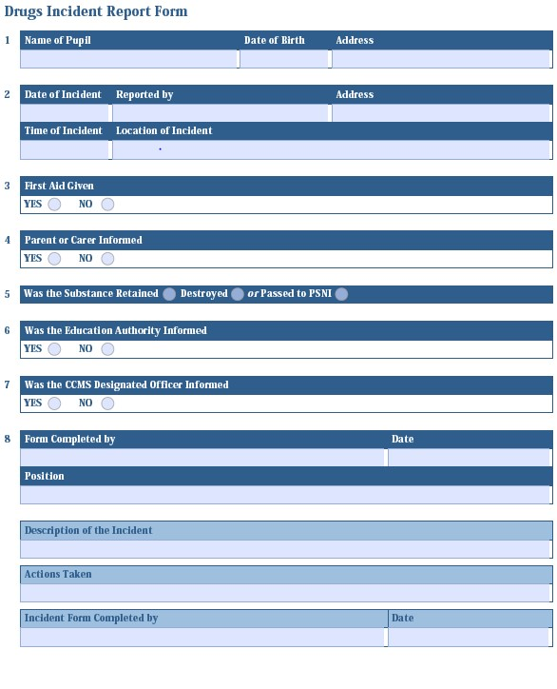

Appendix 2

Checklist of Roles and Responsibilities When Managing an Incident

Individual staff members should:
- assess the situation and decide the action;
- make the situation safe for all pupils and other members of staff, secure first aid and send for additional staff support, if necessary;
- carefully gather up any drugs and/or associated paraphernalia or evidence and pass all information or evidence to the designated teacher for drugs; and
- write a brief factual report of the incident and forward it to the designated teacher for drugs.

The designated teacher for drugs/Principal should:
- respond to first aider's advice or recommendations;
- inform parents or carers immediately, in the case of an emergency;
- take possession of any substance(s) and associated paraphernalia found;
- take initial responsibility for pupil(s) involved in the suspected incident; and
- complete a Drugs Incident Report Form (see Appendix 5)
- determine the circumstances surrounding the incident;
- ensure that the following people are informed:
- parents or carers;
- designated officer in the local PSNI area;
- Board of Governors; and
- designated officer in Education Authority or CCMS.
- consult and agree pastoral and disciplinary responses, including counselling services or support;
- forward a copy of the Incident Report Form to the chairperson of the Board of Governors and the designated officer in the Education Authority or CCMS, if appropriate; and
- review procedures and amend, if necessary

Appendix 3
Main Types of Controlled Substances by Class

The Misuse of Drugs Act (1971)

Class | Substance | Possession | Supply and production
A | Crack cocaine, cocaine, ecstasy (MDMA),  heroin, LSD, magic mushrooms, methadone,  methamphetamine  (crystal meth) | Up to 7 years in prison, an unlimited fine or both | Up to life in prison, an unlimited fine or both
B | Amphetamines, barbiturates, cannabis, codeine, methylphenidate (Ritalin), synthetic cannabinoids, synthetic cathinones (for example mephedrone or methoxetamine) | Up to 5 years in prison, an unlimited fine or both | Up to 14 years in prison, an unlimited fine or both
C | Anabolic steroids, benzodiazepines (diazepam),  gamma hydroxybutyrate  (GHB), gammabutyrolactone (GBL), ketamine, piperazines  (BZP) | Up to 2 years in prison, an unlimited fine or both | Up to 14 years in prison, an unlimited fine or both
Temporary class substance | NBOMe and Benzofuran compounds | None, but police can take away a suspected temporary class substance | Up to 14 years in prison,  an unlimited fine or both

www.gov.uk/penalties-drug-possession-dealing

Please note the above table refers to some commonly available drugs. It is not a complete list of controlled drugs.

Appendix 4

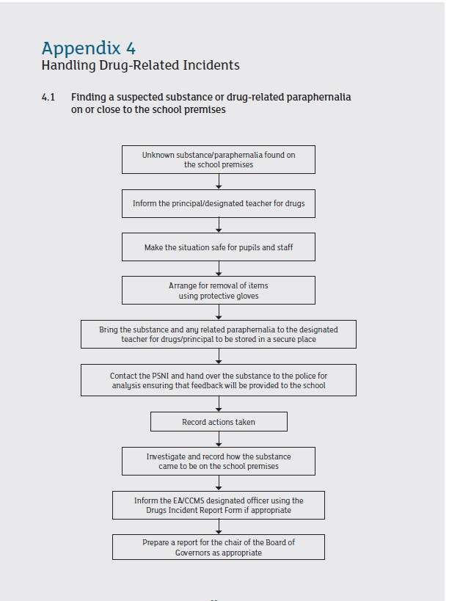
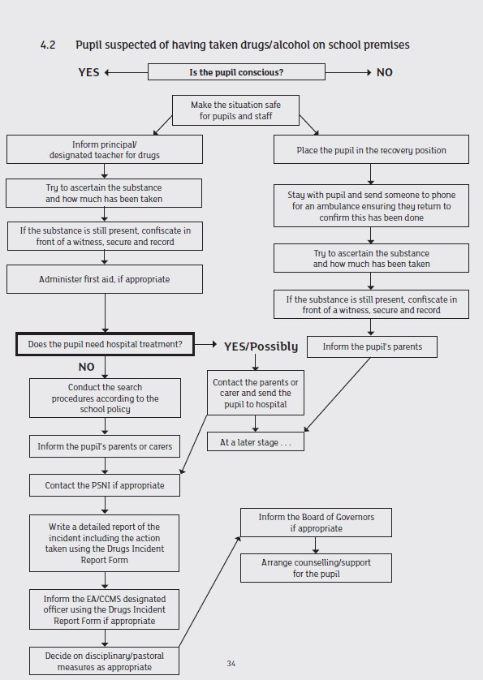
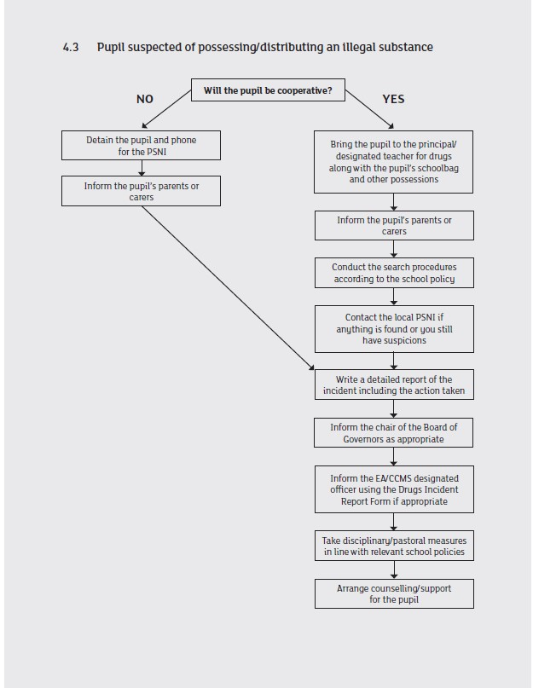
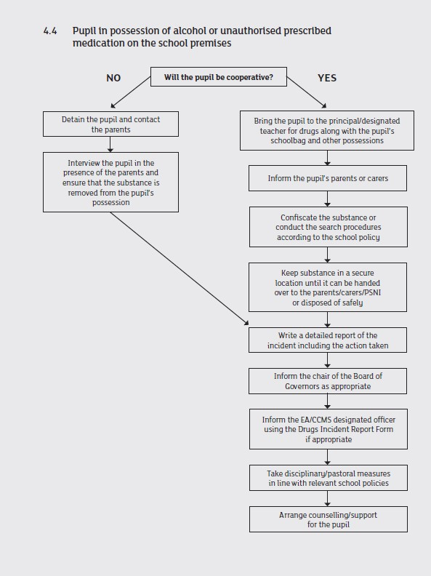
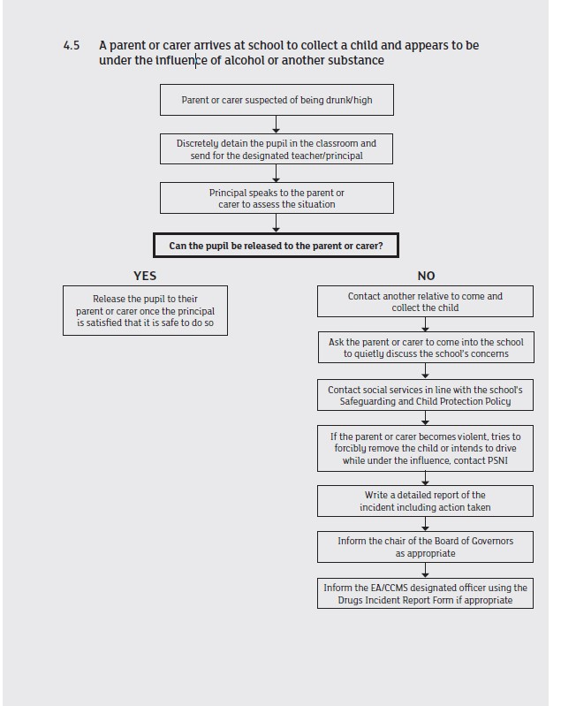

Appendix 5
Recognising Signs of Substance Use
What to look out for
If someone is having a bad time on drugs, they may be:
- anxious; • tense;
- panicky;
- overheated and dehydrated;
- drowsy; or
- having difficulty with breathing.
What to do
The first things you should do are:
- stay calm;
- calm them and be reassuring, don’t scare them or chase after them;
- try to find out what they’ve taken; and
- stay with them.
If they are anxious, tense or panicky, you should:
- sit them in a quiet and calm room;
- keep them away from crowds, bright lights and loud noises;
- tell them to take slow deep breaths; and
- stay with them.
If they are really drowsy, you should:
- sit them in a quiet place and keep them awake;
- if they become unconscious or don’t respond, call an ambulance immediately and place them in the recovery position;
- don’t scare them, shout at them or shock them;
- don’t give them coffee to wake them up; and
- don’t put them in a cold shower to ‘wake them up’.
If they are unconscious or having difficulty breathing, you should:
- immediately phone for an ambulance;
- place them into the recovery position;
- stay with them until the ambulance arrives; and
- if you know what drug they’ve taken, tell the ambulance crew; this can help make sure that they get the right treatment straight away.

Appendix 6
