Good Shepherd Primary & Nursery School
Care in the Sun Policy

UNCRC Article 24
Every child has the right to the best possible health. Governments must provide good quality health care, clean water, nutritious food and a clean environment so that children can stay healthy.

Signed by the Chair of the Board of Governors: ____________________________

Date:_______________________

Rationale:
Skin cancer is one of the most common cancers in the U.K. and the number of cases is rising at an alarming rate. The good news is that the majority of cases could be prevented. If we protect ourselves from the sun, we can reduce our risk. This is particularly important for children and young people whose skin is more delicate and easily damaged.

In Good Shepherd Primary & nursery School we want staff and pupils to enjoy the sun safely. We will work with staff, pupils and parents to achieve this through:

Preventative Curriculum:
The key cancer prevention messages are:
Slip into something cool especially with long sleeves.
Slop on factor 30+
Slap on a hat and sunglasses
Seek the shade during the warmest times of the day 11am-3pm
Slide on your sunglasses.

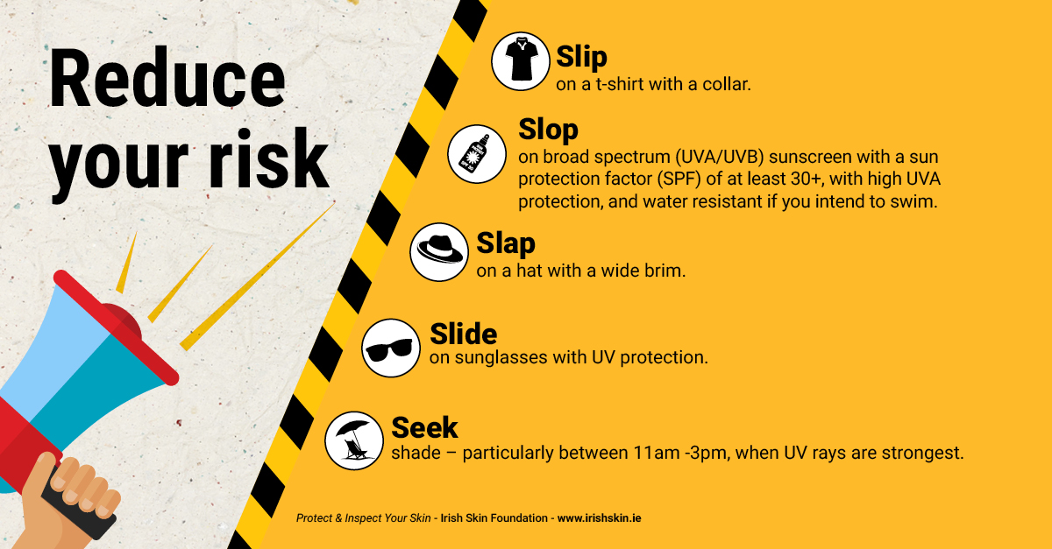

School Practice
- To raise awareness among children of the dangers of excessive sun exposure.
- To create a suitable outside environment that has adequate areas of shade and protection.
- Sun awareness and sun safety issues will be addressed in the appropriate curricular areas, particularly the World Around Us, PDMU and PE.
- Sun safety awareness will also be shared at Assembly during the third term.
- We will address the issue of using clothing as protection: PE kit for outdoor activities, collared t-shirts & shirts, use of hats etc.
- Children are encouraged to use shaded areas of the playground on days when the sun is particularly strong, e.g. shade from trees, walls, buildings, garden structures.
- Children are also encouraged to drink plenty of water as part of their care in the sun routine.
- Appropriate precautions are taken on trips, after-school activities and sports day etc…
- Sun safety will also be considering in risk assessments where appropriate.
- We encourage the use of sun screen/creams in school and will remind parents via website/schools NI app/social media to apply sun cream on particularly warm days before their child attends school that day.

- Sun screen/creams will not be provided by, or applied to children by any staff member.

- Classes will as far as possible, in extreme weather, have play and P.E. sessions in the morning, when the sun is not so strong. This will also apply to Sports Day.

- Parents and guardians will be advised by staff to send with their children a hat to wear in sunny weather.

Staff
All staff are familiar with these guidelines and will ensure that they are correctly implemented. Staff will follow protection procedures and will act as role models. We will endeavour to convey a positive message so that children can enjoy outdoor safety by being “sun wise”.

This policy will be monitored, reviewed and amended as required.

