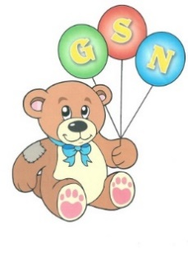
Dear Parents,
We were looking forward to welcoming all our
boys and girls back to start the new year at Nursery. However, at present, it is not safe to do so, we must follow guidance and move to remote learning.
In order to facilitate an interactive approach, we need to switch to ‘seesaw class’. Please download the the ‘ seesaw class app’

A new home learning code is needed and these will be available to pick up from the main entrance of the school. These will be available on Thursday 7th & Friday 8th.
Remote learning will start on Monday 11th January, your class teacher will post learning activities on Seesaw. We understand the pressure families are under, therefore these are only suggested activities.
If your child would like, this new app will enable them to send the Nursery staff pictures and messages.
Stay Safe everyone!
Thank- you for being so understanding during these difficult times!

